What is boosting?
While studying machine learning you must have come across this term called Boosting. It is the most misinterpreted term in the field of Data Science. The principle behind boosting algorithms is first we built a model on the training dataset, then a second model is built to rectify the errors present in the first model. Let me try to explain to you what exactly does this means and how does this works.
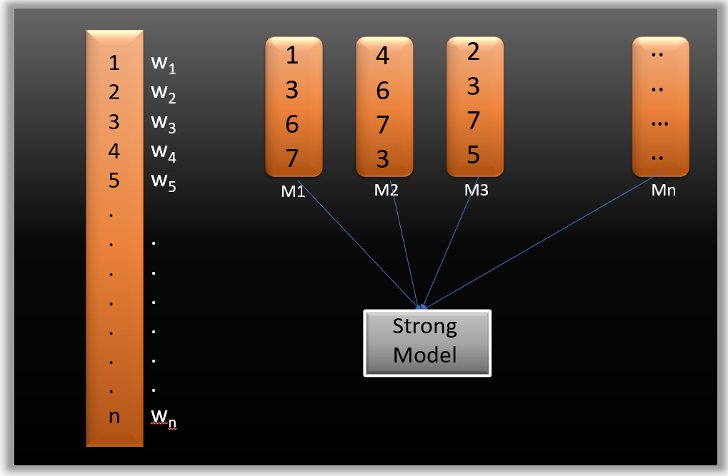
Suppose you have n data points and 2 output classes (0 and 1). You want to create a model to detect the class of the test data. Now what we do is randomly select observations from the training dataset and feed them to model 1 (M1), we also assume that initially, all the observations have an equal weight that means an equal probability of getting selected.
Remember in ensembling techniques the weak learners combine to make a strong model so here M1, M2, M3….Mn all are weak learners.
Since M1 is a weak learner, it will surely misclassify some of the observations. Now before feeding the observations to M2 what we do is update the weights of the observations which are wrongly classified. You can think of it as a bag that initially contains 10 different color balls but after some time some kid takes out his favorite color ball and put 4 red color balls instead inside the bag. Now off-course the probability of selecting a red ball is higher. This same phenomenon happens in Boosting techniques, when an observation is wrongly classified, its weight get’s updated and for those which are correctly classified, their weights get decreased. The probability of selecting a wrongly classified observation gets increased hence in the next model only those observations get selected which were misclassified in model 1.
Similarly, it happens with M2, the wrongly classified weights are again updated and then fed to M3. This procedure is continued until and unless the errors are minimized, and the dataset is predicted correctly. Now when the new datapoint comes in (Test data) it passes through all the models (weak learners) and the class which gets the highest vote is the output for our test data.

What is a Gradient boosting Algorithm?
The main idea behind this algorithm is to build models sequentially and these subsequent models try to reduce the errors of the previous model. But how do we do that? How do we reduce the error? This is done by building a new model on the errors or residuals of the previous model.
When the target column is continuous, we use Gradient Boosting Regressor whereas when it is a classification problem, we use Gradient Boosting Classifier. The only difference between the two is the “Loss function”. The objective here is to minimize this loss function by adding weak learners using gradient descent. Since it is based on loss function hence for regression problems, we’ll have different loss functions like Mean squared error (MSE) and for classification, we will have different for e.g log-likelihood.

Understand Gradient Boosting Algorithm with example
Let’s understand the intuition behind Gradient boosting with the help of an example. Here our target column is continuous hence we will use Gradient Boosting Regressor.
Following is a sample from a random dataset where we have to predict the car price based on various features. The target column is price and other features are independent features.

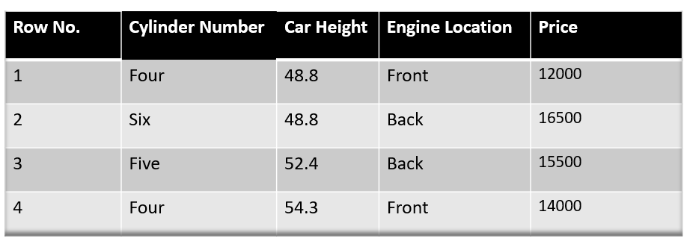
Step -1 The first step in gradient boosting is to build a base model to predict the observations in the training dataset. For simplicity we take an average of the target column and assume that to be the predicted value as shown below:

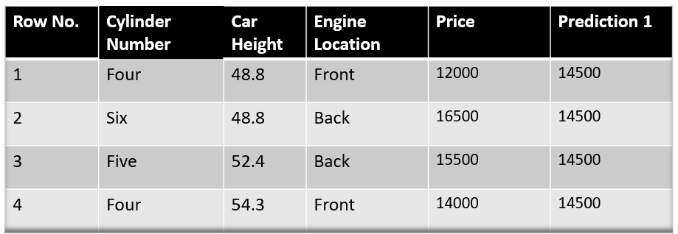
Why did I say we take the average of the target column? Well, there is math involved behind this. Mathematically the first step can be written as:

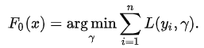

Looking at this may give you a headache, but don’t worry we will try to understand what is written here.
Here L is our loss function
Gamma is our predicted value
argmin means we have to find a predicted value/gamma for which the loss function is minimum.
Since the target column is continuous our loss function will be:

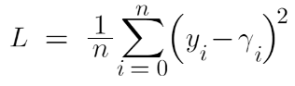
Here y_{i} is the observed value
And gamma is the predicted value
Now we need to find a minimum value of gamma such that this loss function is minimum. We all have studied how to find minima and maxima in our 12th grade. Did we use to differentiate this loss function and then put it equal to 0 right? Yes, we will do the same here.

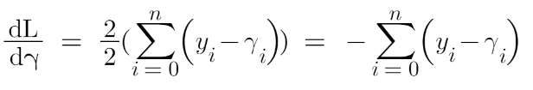
Let’s see how to do this with the help of our example. Remember that y_i is our observed value and gamma_i is our predicted value, by plugging the values in the above formula we get:

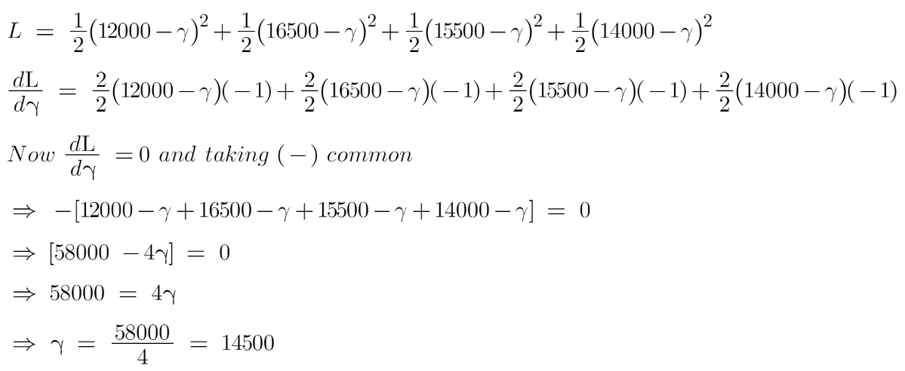
We end up over an average of the observed car price and this is why I asked you to take the average of the target column and assume it to be your first prediction.
Hence for gamma=14500, the loss function will be minimum so this value will become our prediction for the base model.
Step-2 The next step is to calculate the pseudo residuals which are (observed value – predicted value)

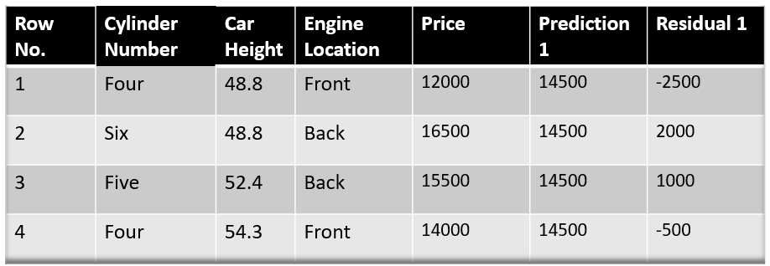
Again the question comes why only observed – predicted? Everything is mathematically proved, let’s from where did this formula come from. This step can be written as:
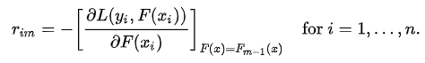
Here F(x_{i}) is the previous model and m is the number of DT made.
We are just taking the derivative of loss function w.r.t the predicted value and we have already calculated this derivative:

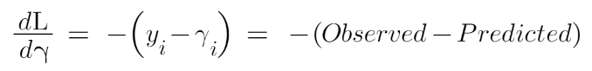
If you see the formula of residuals above, we see that the derivative of the loss function is multiplied by a negative sign, so now we get:

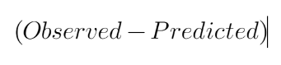
The predicted value here is the prediction made by the previous model. In our example the prediction made by the previous model (initial base model prediction) is 14500, to calculate the residuals our formula becomes:

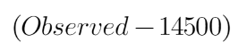
In the next step, we will build a model on these pseudo residuals and make predictions. Why do we do this? Because we want to minimize these residuals and minimizing the residuals will eventually improve our model accuracy and prediction power. So, using the Residual as target and the original feature Cylinder number, cylinder height, and Engine location we will generate new predictions. Note that the predictions, in this case, will be the error values, not the predicted car price values since our target column is an error now.
Let’s say h_{m}(x) is our DT made on these residuals.
Step- 4 In this step we find the output values for each leaf of our decision tree. That means there might be a case where 1 leaf gets more than 1 residual, hence we need to find the final output of all the leaves. TO find the output we can simply take the average of all the numbers in a leaf, doesn’t matter if there is only 1 number or more than 1.
Let’s see why do we take the average of all the numbers. Mathematically this step can be represented as:

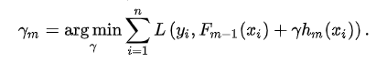
Here h_{m}(x_{i}) is the DT made on residuals and m is the number of DT. When m=1 we are talking about the 1st DT and when it is “M” we are talking about the last DT.
The output value for the leaf is the value of gamma that minimizes the Loss function. The left-hand side “Gamma” is the output value of a particular leaf. On the right-hand side [F_{m-1}(x_{i})+ƴh_{m}(x_{i}))] is similar to step 1 but here the difference is that we are taking previous predictions whereas earlier there was no previous prediction.
Let’s understand this even better with the help of an example. Suppose this is our regressor tree:
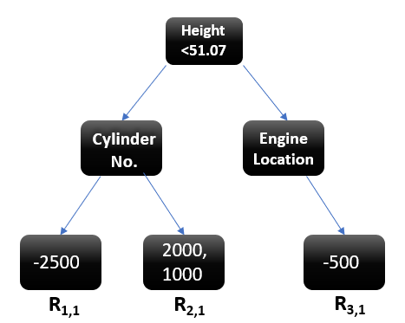
We see 1st residual goes in R_{1,1} ,2nd and 3rd residuals go in R_{2,1} and 4th residual goes in R_{3,1} .
Let’s calculate the output for the first leave that is R_{1,1}
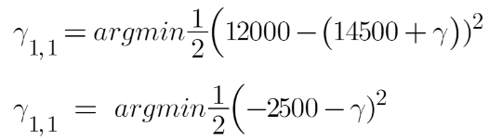
Now we need to find the value for gamma for which this function is minimum. So we find the derivative of this equation w.r.t gamma and put it equal to 0.
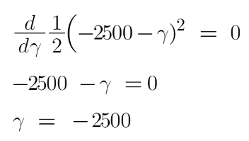
Hence the leaf R_{1,1} has an output value of -2500. Now let’s solve for the R_{2,1}
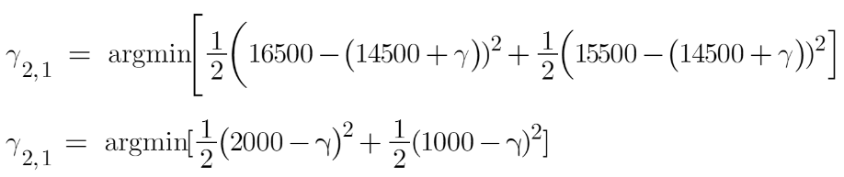
Let’s take the derivative to get the minimum value of gamma for which this function is minimum:
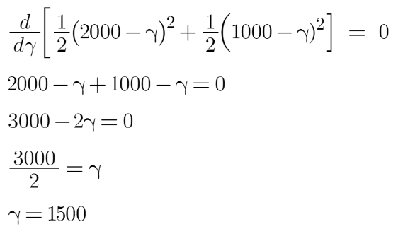
We end up with the average of the residuals in the leaf R_{2,1} . Hence if we get any leaf with more than 1 residual, we can simply find the average of that leaf and that will be our final output.
Now after calculating the output of all the leaves, we get:
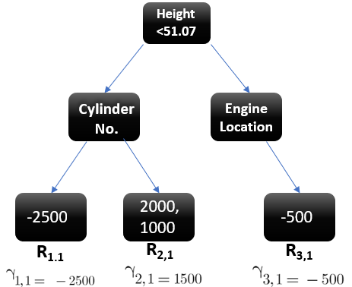Image Source:
Step-5 This is finally the last step where we have to update the predictions of the previous model. It can be updated as:
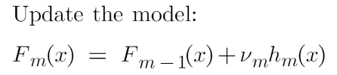
where m is the number of decision trees made.
Since we have just started building our model so our m=1. Now to make a new DT our new predictions will be:


Here F_{m-1}(x) is the prediction of the base model (previous prediction) since F₁₋₁₌₀ , F₀ is our base model hence the previous prediction is 14500.
nu is the learning rate that is usually selected between 0-1. It reduces the effect each tree has on the final prediction, and this improves accuracy in the long run. Let’s take nu=0.1 in this example.
H_{m}(x) is the recent DT made on the residuals.
Let’s calculate the new prediction now:
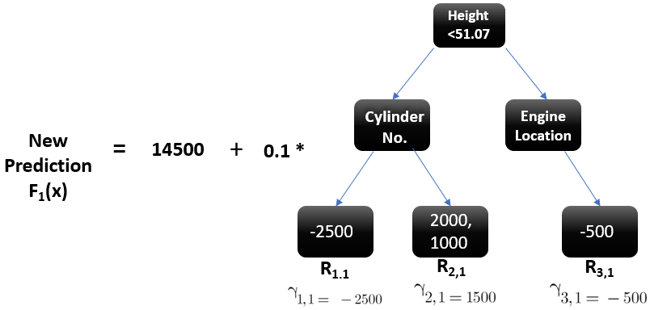
Suppose we want to find a prediction of our first data point which has a car height of 48.8. This data point will go through this decision tree and the output it gets will be multiplied with the learning rate and then added to the previous prediction.
Now let’s say m=2 which means we have built 2 decision trees and now we want to have new predictions.
This time we will add the previous prediction that is F₁(x) to the new DT made on residuals. We will iterate through these steps again and again till the loss is negligible.
I am taking a hypothetical example here just to
make you understand how this predicts for a new dataset:

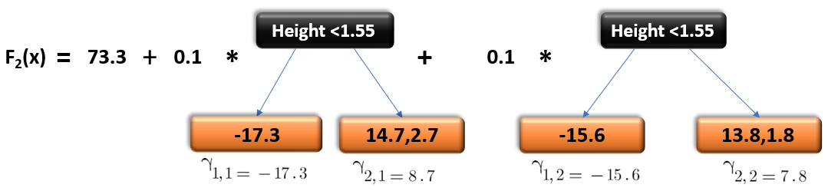

If a new data point says height = 1.40 comes, it’ll go through all the trees and then will give the prediction. Here we have only 2 trees hence the datapoint will go through these 2 trees and the final output will be F₂(x).

What is Gradient Boosting Classifier?
A gradient boosting classifier is used when the target column is binary. All the steps explained in the Gradient boosting regressor are used here, the only difference is we change the loss function. Earlier we used Mean squared error when the target column was continuous but this time, we will use log-likelihood as our loss function.
Let’s see how this loss function works, the loss function for the classification problem is given below:
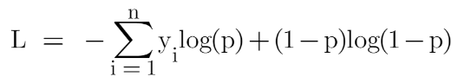
Our first step in the gradient boosting algorithm was to initialize the model with some constant value, there we used the average of the target column but here we’ll use log(odds) to get that constant value. The question comes why log(odds)?
When we differentiate this loss function, we will get a function of log(odds) and then we need to find a value of log(odds) for which the loss function is minimum.
Confused right? Okay let’s see how it works:
Let’s first transform this loss function so that it is a function of log(odds), I’ll tell you later why we did this transformation.
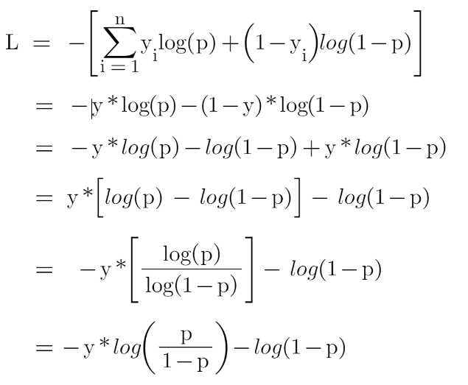
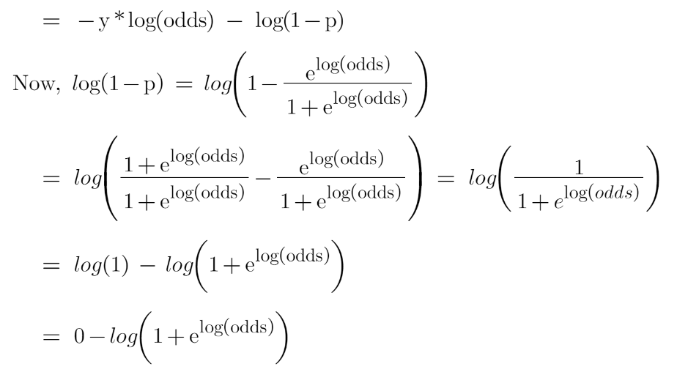
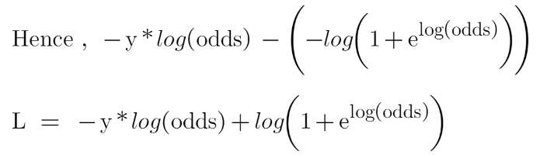
Now this is our loss function, and we need to minimize it, for this, we take the derivative of this w.r.t to log(odds) and then put it equal to 0,
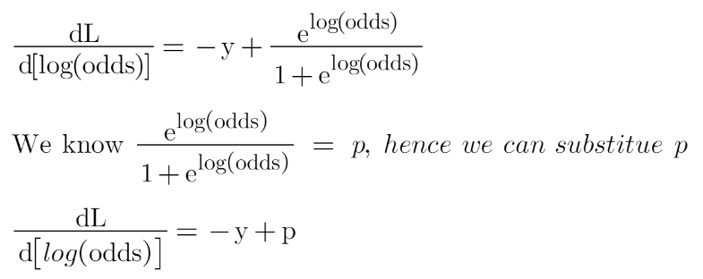
Here y are the observed values
You must be wondering that why did we transform the loss function into the function of log(odds). Actually, sometimes it is easy to use the function of log(odds), and sometimes it’s easy to use the function of predicted probability “p”.
It is not compulsory to transform the loss function, we did this just to have easy calculations.
Hence the minimum value of this loss function will be our first prediction (base model prediction)
Now in the Gradient boosting regressor our next step was to calculate the pseudo residuals where we multiplied the derivative of the loss function with -1. We will do the same but now the loss function is different, and we are dealing with the probability of an outcome now.
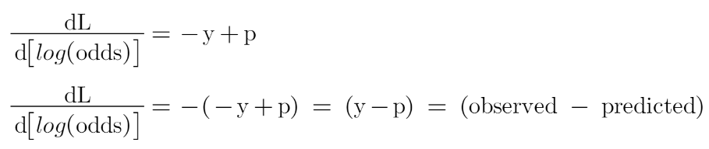
After finding the residuals we can build a decision tree with all independent variables and target variables as “Residuals”.
Now when we have our first decision tree, we find the final output of the leaves because there might be a case where a leaf gets more than 1 residuals, so we need to calculate the final output value. The math behind this step is out of the scope of this article so I will mention the direct formula to calculate the output of a leaf:
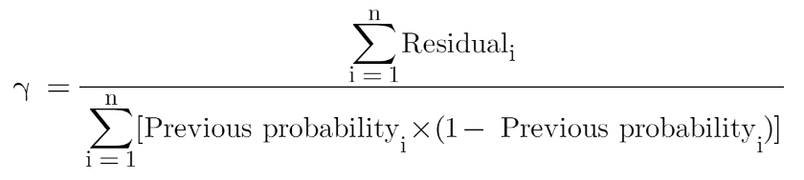
Finally, we are ready to get new predictions by adding our base model with the new tree we made on residuals.

This is a Python code for a simple implementation of the XGBoost algorithm. Here is an explanation of each part of the code:
- import numpy as np: This imports the NumPy library as np, which is used for mathematical computations in Python.
- class XGBoost:: This defines a class called XGBoost that contains methods for training and predicting with the XGBoost algorithm.
- def __init__(self, num_rounds=100, learning_rate=0.1, max_depth=3): This is a constructor method for the XGBoost class. It sets default values for the number of rounds (iterations), learning rate, and maximum depth of the tree.
- self.num_rounds = num_rounds: This sets the value of num_rounds as an attribute of the XGBoost class.
- self.learning_rate = learning_rate: This sets the value of learning_rate as an attribute of the XGBoost class.
- self.max_depth = max_depth: This sets the value of max_depth as an attribute of the XGBoost class.
- def fit(self, X, y): This is a method for training the XGBoost model. It takes in two arguments, X (the input data) and y (the output labels), and fits the model to the data.
- w = np.ones(len(y)): This creates an array of ones with the same length as y.
- z = np.zeros(len(y)): This creates an array of zeros with the same length as y.
- for r in range(self.num_rounds): This starts a loop that iterates over the number of rounds specified in the constructor method.
- g = -(y - (1 / (1 + np.exp(-z)))): This calculates the gradient of the loss function used in the XGBoost algorithm.
- h = (1 / (1 + np.exp(z))) * (1 - (1 / (1 + np.exp(z)))): This calculates the second derivative (Hessian) of the loss function used in the XGBoost algorithm.
- leaf_weights = -(np.sum(g) / (np.sum(h) + 1e-6)): This calculates the weights for the leaves of the decision tree used in the XGBoost algorithm.
- w *= np.exp(-self.learning_rate * (g / (h + 1e-6))): This updates the model weights for each round of the algorithm.
- z = np.log((1 - w) / w): This updates the variable z, which is used to calculate the gradient and Hessian in the next round.
- self.leaf_weights = leaf_weights: This saves the leaf weights as an attribute of the XGBoost class.
- def predict(self, X): This is a method for making predictions with the XGBoost model. It takes in one argument, X (the input data), and returns the predicted output.
- preds = 1 / (1 + np.exp(-self.leaf_weights * X)): This calculates the predicted output using the leaf weights and the input data.
- return preds: This returns the predicted output.

LightGBM is a gradient boosting framework that is designed to be efficient, scalable, and accurate. It was developed by Microsoft and is open source. LightGBM is designed to handle large-scale datasets with millions of examples and hundreds of features, and it uses a novel technique called Gradient-based One-Side Sampling (GOSS) to speed up the training process.
Some of the key characteristics of LightGBM include:
- Speed: LightGBM is designed to be fast and efficient, with support for parallel and distributed computing.
- Memory efficiency: LightGBM uses a technique called Histogram-based Gradient Boosting, which reduces memory usage by binning continuous features into discrete bins.
- Accuracy: LightGBM uses a leaf-wise approach to building decision trees, which can lead to better accuracy than the level-wise approach used in other gradient boosting frameworks.
- Scalability: LightGBM can handle large-scale datasets with millions of examples and hundreds of features.
- Customizability: LightGBM provides a wide range of hyperparameters that can be tuned to optimize performance for specific tasks.
- GPU support: LightGBM has support for GPU acceleration, which can significantly speed up the training process for large-scale datasets.
Overall, LightGBM is a powerful and flexible framework for building high-performance gradient boosting models, particularly for large-scale datasets. Its speed, memory efficiency, and accuracy make it a popular choice for many machine learning tasks.

The working of LightGBM can be summarized in the following steps:
- Data preparation: The first step is to prepare the data for training. This includes loading the data, splitting it into training and validation sets, and encoding any categorical features.
- Building the trees: LightGBM builds a decision tree by iteratively splitting the data into two subsets based on a chosen feature and threshold. The algorithm uses a leaf-wise approach, meaning that it grows the tree by adding leaves one at a time, and each leaf is expanded in a depth-first fashion until a stopping criterion is met.
- Split finding: In order to find the best split at each node, LightGBM uses a Histogram-based approach, which bin the continuous features into discrete bins, and then builds histograms of the feature values at each node to find the best split. This approach reduces the memory usage and speeds up the training process.
- Gradient-based One-Side Sampling (GOSS): LightGBM uses a technique called Gradient-based One-Side Sampling (GOSS) to reduce the number of data instances used in the training process, without sacrificing accuracy. GOSS selects instances with larger gradients for training, while discarding instances with small gradients, leading to faster training times.
- Regularization: LightGBM uses two forms of regularization to prevent overfitting: L1 regularization, which adds a penalty term to the loss function based on the absolute value of the weights, and L2 regularization, which adds a penalty term based on the square of the weights.
- Learning rate and early stopping: LightGBM uses a learning rate to control the step size during gradient descent. A lower learning rate leads to slower training times but may lead to better accuracy. LightGBM also employs early stopping to prevent overfitting, by stopping the training process when the validation error does not improve for a certain number of iterations.
- Prediction: Once the trees are built, LightGBM uses them to make predictions on new data. It does this by following the decision path down the tree for each instance and computing the weighted sum of the leaf values, which gives the predicted value.
Overall, LightGBM's combination of histogram-based split finding, GOSS, and leaf-wise growth makes it a highly efficient and scalable framework for building gradient boosting models.

Here are some of the key equations used in LightGBM:
- Gradient boosting: The goal of gradient boosting is to minimize the loss function L, which is defined as the difference between the true label y and the predicted label f(x), where x is the input feature vector. At each iteration of the algorithm, a weak learner (decision tree) is fit to the residual values, or the difference between the true label and the current prediction:
L(y, f(x)) = (y - f(x))
- Histogram-based split finding: LightGBM uses a histogram-based approach to find the best split point for each feature. This involves discretizing the continuous feature values into discrete bins, and constructing a histogram of the feature values at each node. Given a histogram H, the algorithm computes the best split point S by minimizing the loss function over all possible split points:
S = argmin(L(H_L, H_R))
where H_L and H_R are the histograms of the left and right child nodes resulting from the split.
- Leaf-wise growth: LightGBM uses a leaf-wise approach to tree growth, where at each iteration, the algorithm selects the leaf node that results in the greatest reduction in the loss function, and then expands that node by adding child nodes. The prediction f(x) for a given instance x is computed as the sum of the leaf values w_j for all the leaves j that x falls into:
f(x) = sum(w_j if x falls into leaf j)
- Regularization: LightGBM uses two forms of regularization to prevent overfitting: L1 regularization, which adds a penalty term to the loss function based on the absolute value of the weights w, and L2 regularization, which adds a penalty term based on the square of the weights:
L1: L = L(y, f(x)) + lambda * sum(abs(w))
L2: L = L(y, f(x)) + lambda * sum(w^2)
where lambda is the regularization parameter.
- Gradient-based One-Side Sampling (GOSS): GOSS is a technique used by LightGBM to reduce the number of data instances used in the training process, without sacrificing accuracy. GOSS selects instances with larger gradients for training, while discarding instances with small gradients. This is done by applying a threshold T to the gradient g:
T = alpha * percentile(|g|)
where alpha is a hyperparameter and percentile is a function that returns the value of the gradient at the specified percentile.
- Learning rate: The learning rate is a hyperparameter in LightGBM that controls the step size during gradient descent. A lower learning rate leads to slower training times but may lead to better accuracy. The updated weights w' are computed as:
w' = w - learning_rate * gradient
where gradient is the negative gradient of the loss function with respect to the weights.

- Gradient-based Feature Importance: LightGBM computes feature importance scores based on the average gain of each feature over all the trees in the model. The gain of a feature is defined as the total reduction in the loss function that is achieved by splitting on that feature:
Gain = sum((H_L + H_R - H) - (H_0_L + H_0_R - H_0))
where H_L and H_R are the histograms of the left and right child nodes resulting from the split, H_0_L and H_0_R are the histograms of the corresponding child nodes in the parent node, and H is the histogram of the parent node.
- Early stopping: LightGBM supports early stopping, which is a technique used to stop the training process early if the validation error stops improving. The validation error is computed using a separate validation set and is evaluated after each iteration. If the validation error does not improve for a specified number of iterations, the training process is stopped.
These equations give a sense of the underlying mathematics behind LightGBM. The algorithm makes use of histogram-based split finding, leaf-wise growth, gradient-based one-side sampling, and regularization to produce accurate and efficient models.

Advantages of LightGBM:
- Faster Training Speed: LightGBM uses a gradient-based One-Side Sampling (GOSS) technique and Exclusive Feature Bundling (EFB) algorithm that results in faster training speed as compared to other boosting algorithms.
- Lower Memory Usage: LightGBM uses a histogram-based algorithm for finding the best split value that uses less memory.
- High Accuracy: LightGBM uses a leaf-wise tree growth algorithm that helps to reduce loss more quickly.
- Better Handling of Large Data: LightGBM is designed to handle large datasets with millions of rows and features, which is not possible in other boosting algorithms.
Disadvantages of LightGBM:
- Prone to Overfitting: LightGBM can easily overfit on small datasets or datasets with imbalanced classes.
- Tuning Parameters: LightGBM has many tuning parameters that can make it challenging to find the optimal set of hyperparameters.
- Lack of Flexibility: LightGBM is primarily designed for binary or multi-class classification and regression problems, which can be a limitation for some applications.
- Requires Preprocessing: LightGBM requires the data to be preprocessed, and missing values must be imputed, which can be time-consuming for large datasets.

